In the absolute mode, permissions are represented in numeric form (octal system to be precise). In this system, each file permission is represented by a number.

* r (read) = 4
* w (write) = 2
* x (execute) = 1
* – (no permission) = 0

With these numeric values, you can combine them and thus one number can be used to represent the entire permission set.

| **Number** | **Permission** |
| --- | --- |
| 0 | — |
| 1 | –x |
| 2 | -w- |
| 3 (i.e. 2+1) | -wx |
| 4 | r– |
| 5 (i.e. 4+1) | r-x |
| 6 (i.e. 4+2) | rw- |
| 7 (i.e. 4+2+1) | rwx |

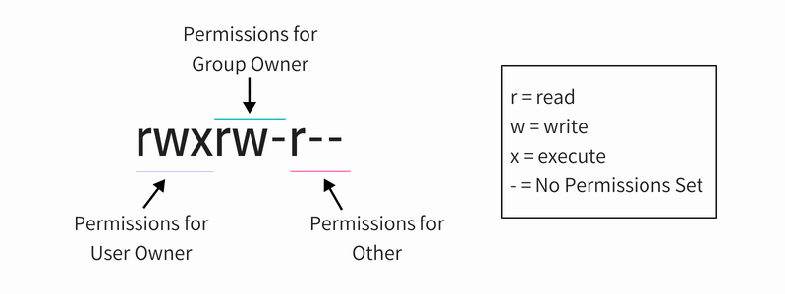

**Change file permissions in Linux**

You can use [chmod](https://linux.die.net/man/1/chmod) command for changing the permissions on a file in Linux.

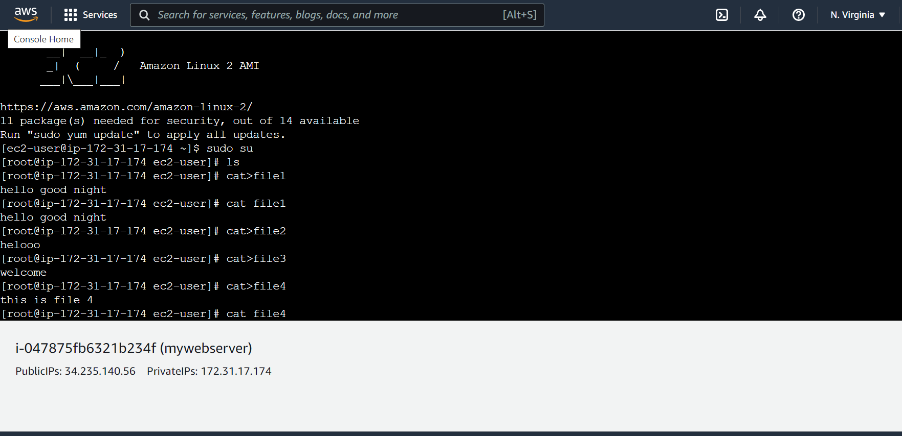

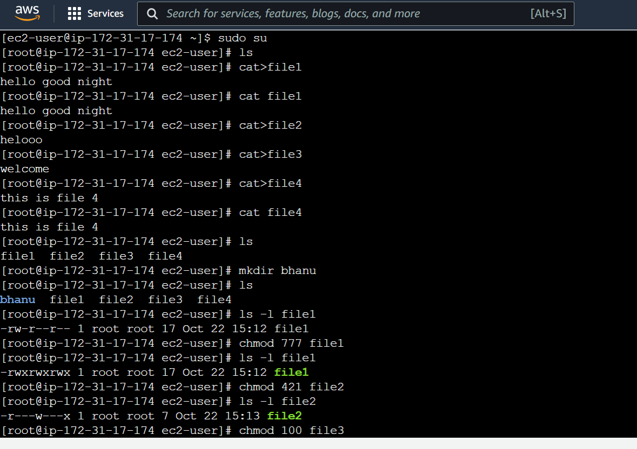

### Using chmod in symbolic mode

The problem with the absolute mode is that you should always provide three numbers for all the three owners even if you want to change the  permission set for just one owner.

This is where you can use the symbolic mode with chmod command.

In symbolic mode, owners are denoted with the following symbols:

* u = user owner
* g = group owner
* o = other
* a = all (user + group + other)
* **Change file ownership in Linux**
* To change the ownership of a file, you can use the [command chown](https://linux.die.net/man/1/chown). You may easily guess that chown stands for change owner.
* You can change the user owner of a file in the following manner:
* chown <new\_user\_name> <filename>

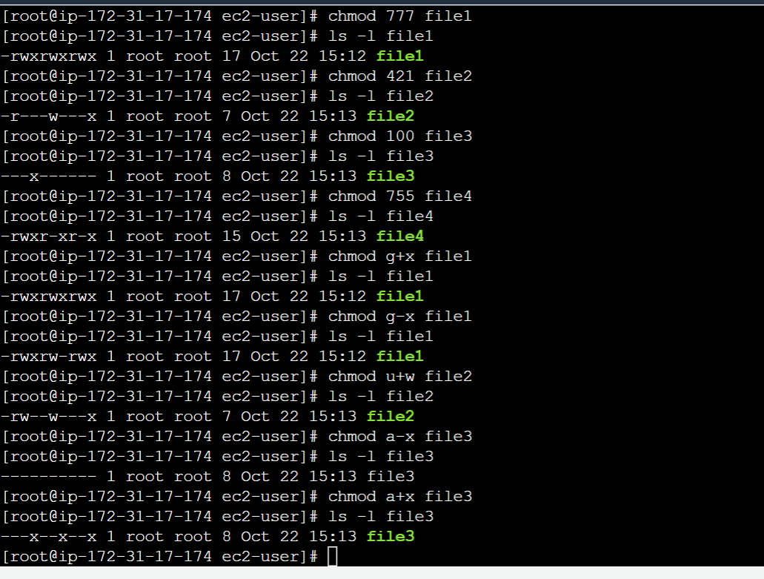

CREATING SHARED DIRECTORY

 start by creating common group using [groupadd](https://www.geeksforgeeks.org/groupadd-command-in-linux-with-examples/" \t "_blank) command.

Now, create shared directory and change group for it using [chgrp](https://www.geeksforgeeks.org/chgrp-command-in-linux-with-examples/" \t "_blank) command.

After this we need to change appropriate permissions for the shared directory using [chmod](https://www.geeksforgeeks.org/chmod-command-linux/" \t "_blank) command.

We also need to set the SGID(Set-Group-ID) bit for the sharedFolder directory, now all newly created subdirectories/files under sharedFolder will inherit sharedFolder permissions. Finally we add users to the common group with whom to share the folder

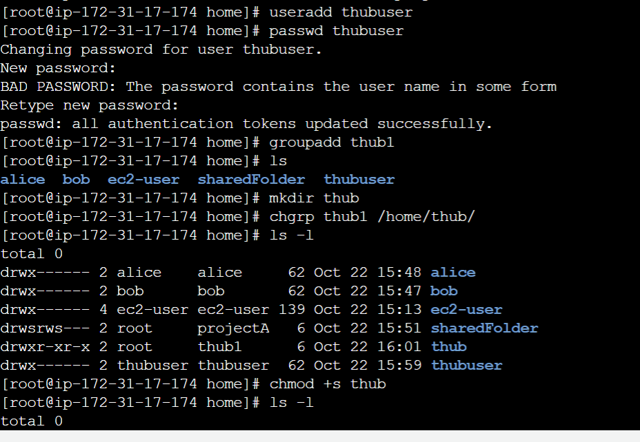

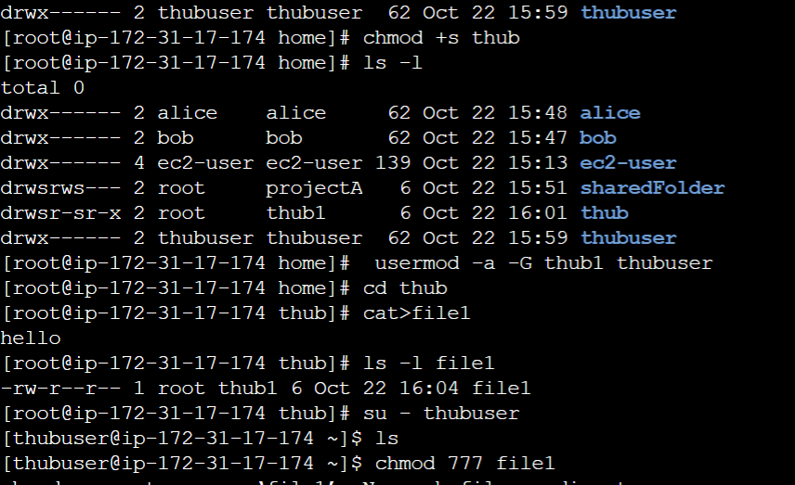

Now **/home/sharedFolder** is accessible to both the user Bob and Alice. But others can’t access this directory. This directory will be accessible to only members of projectA group.